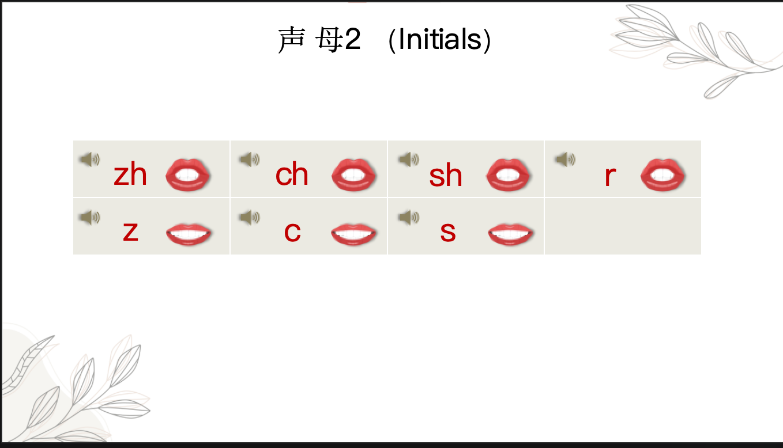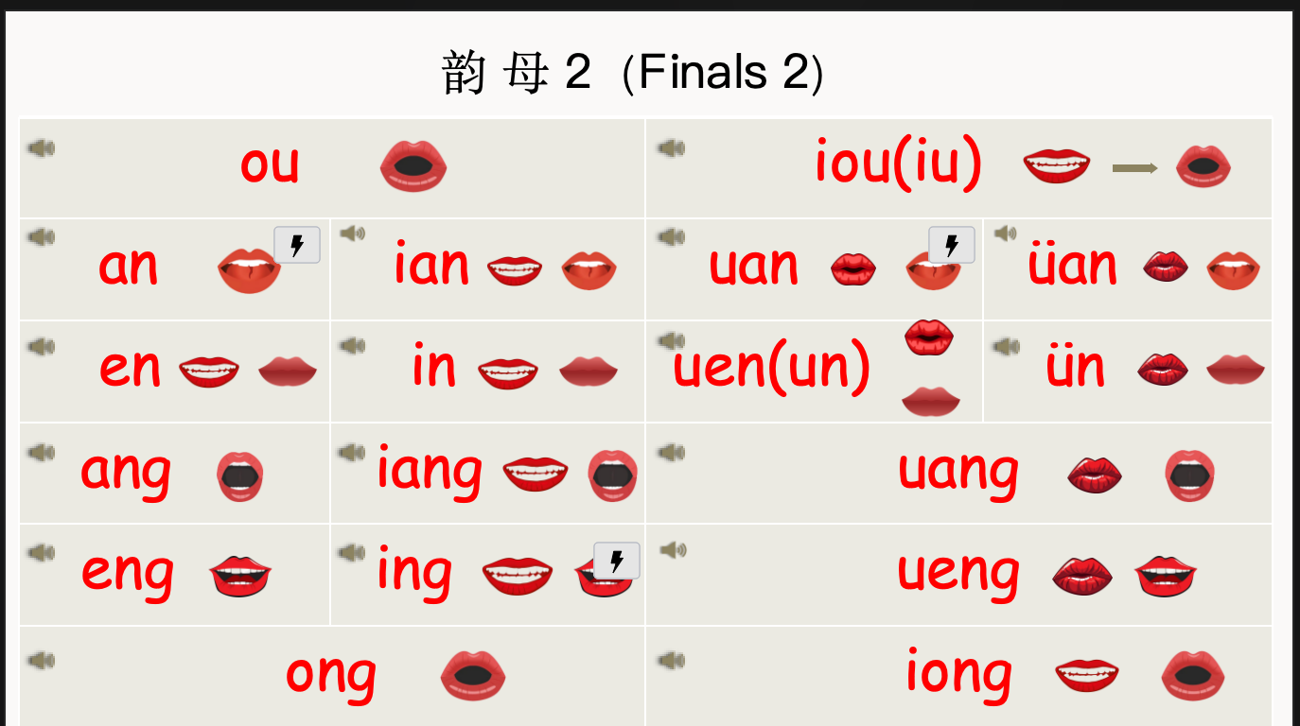

New volabulary  
谢谢（xiè xie） to thank

不（ bù ） adv. no, not

不谢（ Bú xiè） You are welcome

不客气（Bú kè qi） You are welcome

再见（ zài jiàn） v. to see you around；Goodbye

**Rules**

1.When ü is spelled with the initials “j q x y”, the two dots on ü need to be removed.

|  |  |  |  |
| --- | --- | --- | --- |
| ǖ  - jū | ǖ  -yū | ǖ  -xū | ǖ  - qū |

2.The Neutral Tone

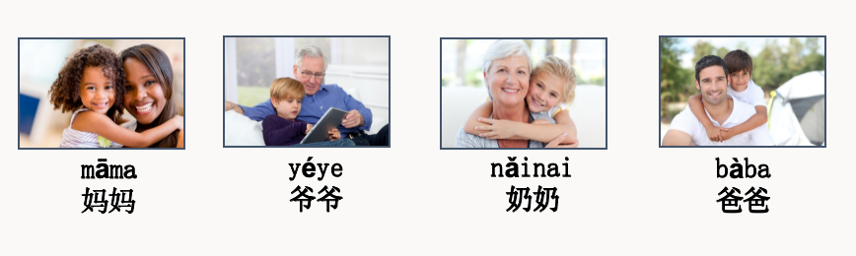

**Rules：**  
1.Tone Sandhi ：When two Chinese characters in third tone are together, the first Chinese character has to become a second tone

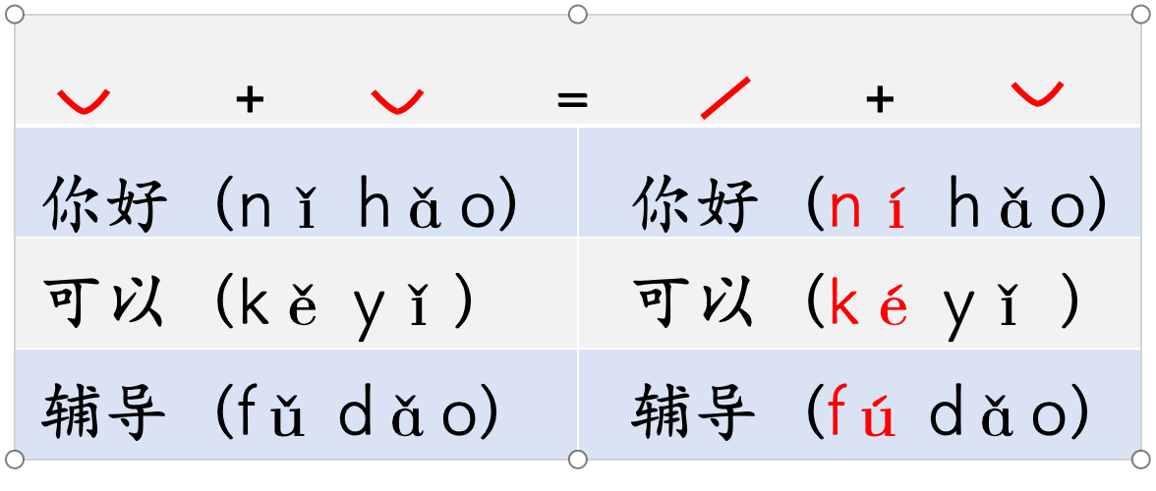

2.Abbreviation

When iou, uei or uen follows an initial, they are written as iu, ui and un respectively, for example, niu, gui, lun.