**A report on working abroad**

The principal of a college has asked you to write a report on the advantages and disadvantages of working abroad in the summer holidays and whether the college should recommend ‘working holidays’ to its students.

**Introduction**

Currently, approximately 25 per cent of Hawthorne College students work abroad during the summer break. This report aims to show the benefits and drawbacks of working overseas in order to decide whether the college should recommend the experience to its students. To prepare for this report, a sample of 100 students were interviewed, 23 of whom had worked abroad. This is a summary of their comments.

**Benefits**

According to the students interviewed, working overseas during the summer holidays can bring several benefits. Most of all, students can improve their foreign language skills by working in a non-English speaking country. This may help them get a better job in the future. Additionally, learning about a different culture and way of life makes people more open minded. A further advantage is that students may become more confident when they learn practical skills to help them live independently later in life, for example, finding accommodation and cooking for themselves.

**Drawbacks**

However, a large number of interviewees mentioned drawbacks as well. Students who need to study over the summer will find it difficult to do so while working abroad. Most significant of all are finance issues: only a minority of students are able to afford travel expenses, accommodation and visas. In addition, students may have to take low-income jobs if they are not fluent in the local language, so they may struggle to cover their expenses.

**Conclusion and recommendation**

Working abroad may improve students’ language skills and confidence. However, students often need to earn money during the holidays to support their studies and working abroad may not provide the opportunity to save. Also, the cost of travel means that only students who are able to afford it have the chance to do this. Therefore, the college should only recommend working abroad if there is financial support from the college for students that need it.

Tips 1. The basic structure of a report is usually the same:

• Introduction (including the purpose of the report and how the data was collected)

• Findings (including benefits and drawbacks if appropriate)

• Conclusion and recommendations.

2. Use headings for each section.

3. Use formal vocabulary (e.g. Currently, ... / in order to ... / Therefore, ...) to give the report a formal style.

4. The ideas and conclusions should be objective. Use non-personal subjects (e.g. This report aims to … ) and passive structures (e.g. 100 students were interviewed).

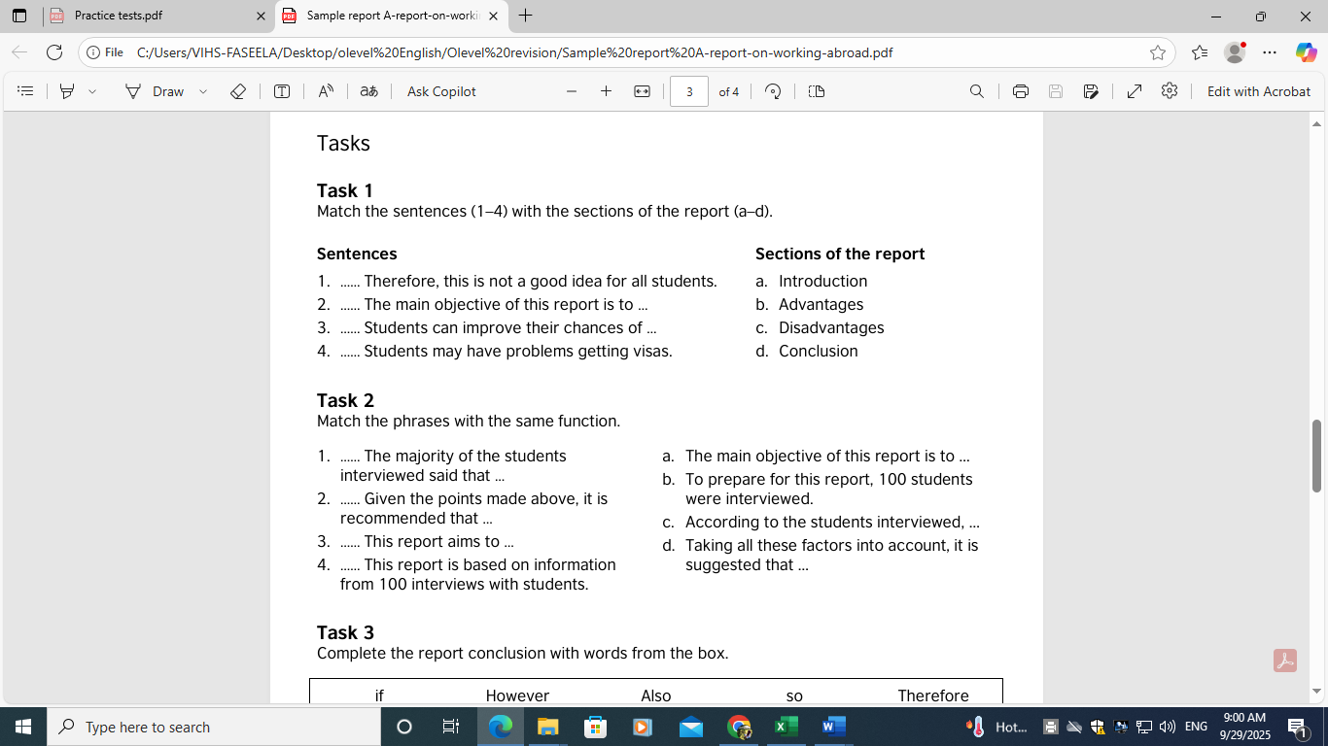

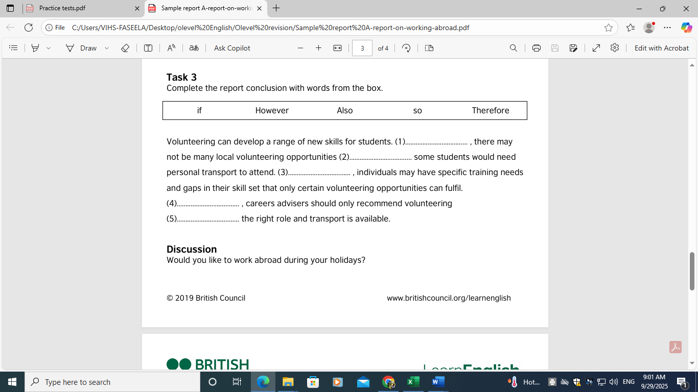

Answers

Task 1 1. d 2. a 3. b 4. c

Task 2 1. c 2. d 3. a 4. b

Task 3 1. However 2. so 3. Also 4. Therefore 5. if