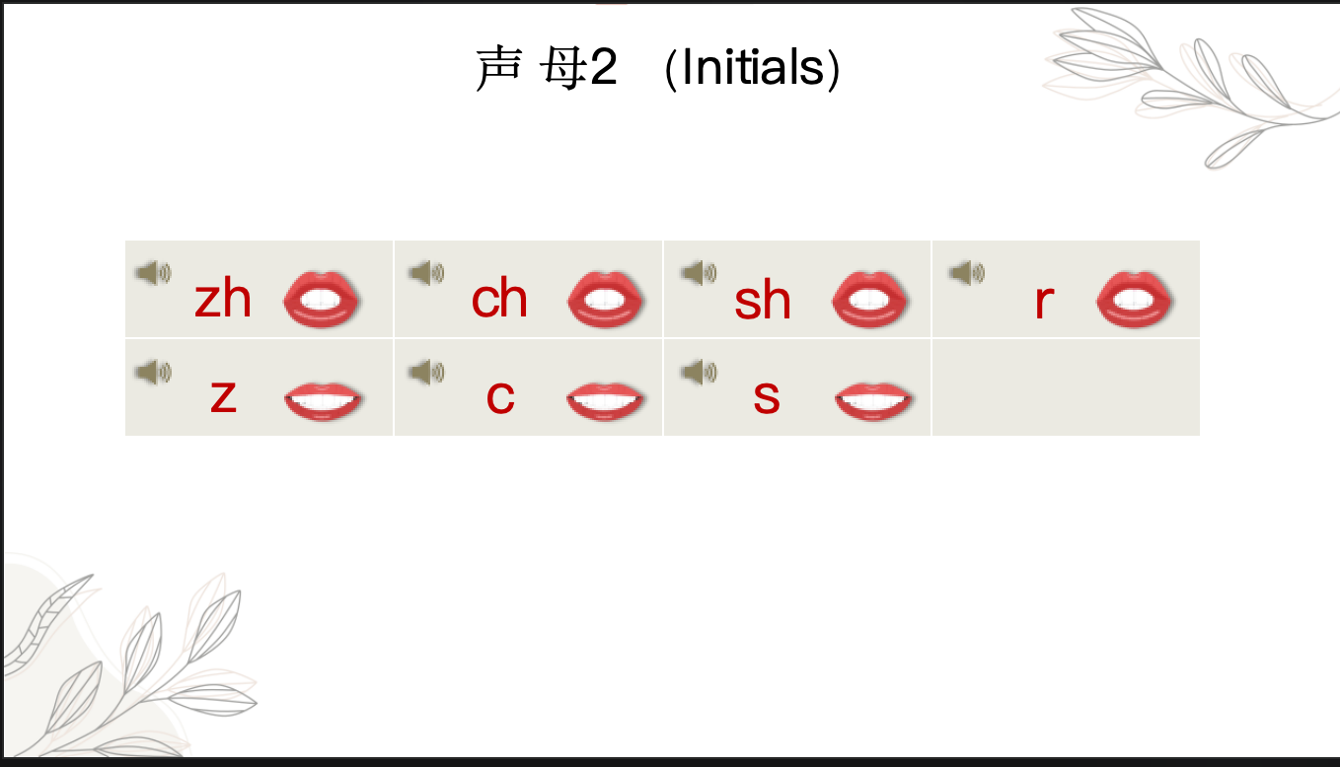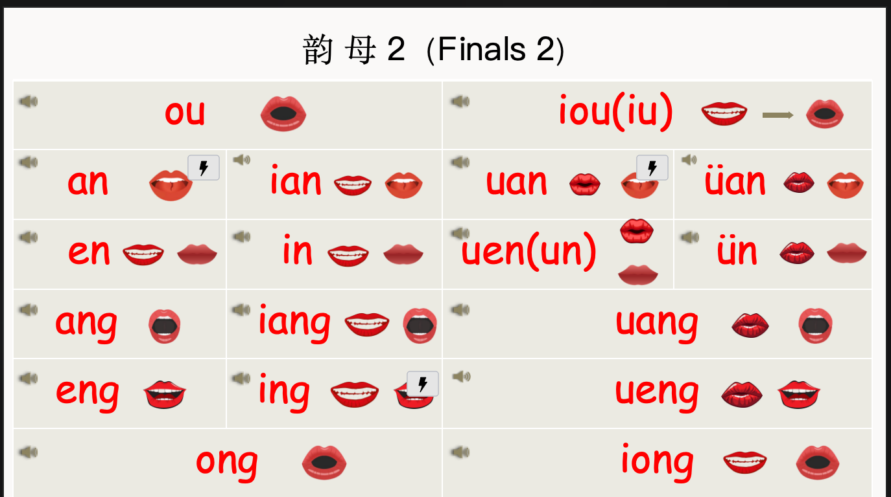
New volabulary
谢谢（xiè xie） to thank
不（ bù ） adv. no, not
不谢（ Bú xiè） You are welcome
不客气（Bú kè qi） You are welcome
再见（ zài jiàn） v. to see you around；Goodbye

Rules
1.When ü is spelled with the initials “j q x y”, the two dots on ü need to be removed.
ǖ - jū | ǖ -yū | ǖ -xū | ǖ - qū

2.The Neutral Tone
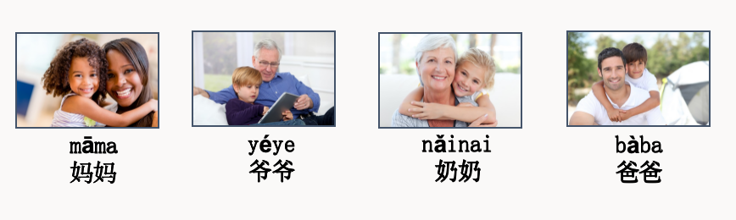

Rules：
1.Tone Sandhi ：When two Chinese characters in third tone are together, the first Chinese character has to become a second tone
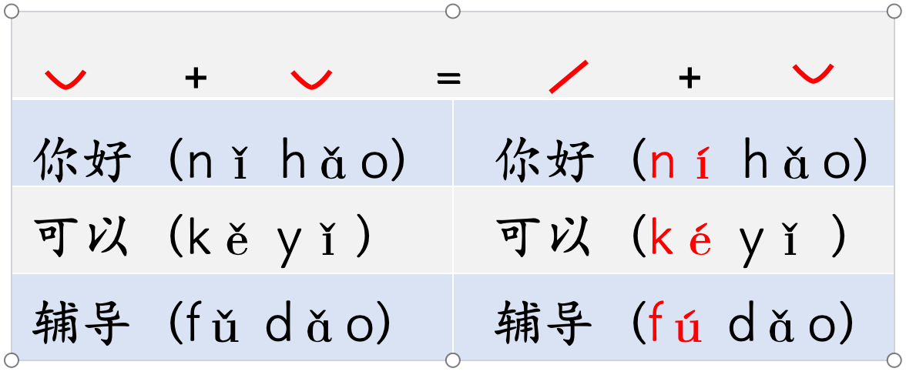

2.Abbreviation
When iou, uei or uen follows an initial, they are written as iu, ui and un respectively, for example, niu, gui, lun.

